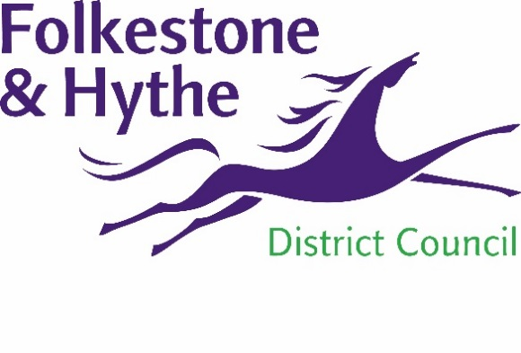
NEWS RELEASE

29 April 2021
SHARE YOUR VIEWS ON THE FUTURE OF FOLKESTONE TOWN CENTRE

More than 180 people tuned in live to the first public Place Plan event which was held last week (Monday 19 April) and now residents are being encouraged to share their views via a short survey to help shape the Folkestone Town Centre Place Plan.

The virtual webinar was run by urbanism consultants We Made That who have been appointed by the council to run the project. The team shared progress on the project to date including their priorities and a selection of ideas that had emerged. As part of the vision for the Place Plan We Made That also presented proposals for exciting potential future changes for Folkestone such as improved access between the town and the harbour and a new public square in Bouverie Place,

A council spokesperson said: “We want residents to think about what could be great additions to Folkestone and to share both this and what they think about the proposals already suggested.

“We were delighted with the level of engagement at our first public event around the Place Plan and hope to get lots of feedback through this survey about what residents do and don’t want.”

The feedback received will help to shape the final Place Plan which is scheduled to be finished by the end of summer.

The full webinar has been recorded and is available online along with the presentation slides detailing specific proposals. The survey is now open for all to complete and this closes on Sunday 9 May. All the information about the Place Plan including the webinar, slides and survey link can be found at folkestone-hythe.gov.uk/folkestoneplaceplan

A survey and printed pack can be made available for those who do not have online access. If necessary this can be requested by calling Folkestone & Hythe District Council on 01303 853000.

ENDS
Notes to Editors:

Folkestone & Hythe District Council has appointed architecture and urbanism experts We Made That to lead on the delivery of a Place Plan for Folkestone Town Centre. The design team brings together a diverse team of specialists; Fletcher Priest to advise on the architecture of specific opportunity sites; transport and infrastructure consultants Steer are looking into town centre access; socio-economic analysts PRD are advising on economy and town centre business opportunities. The Night Time Industry Association are providing support to review the existing licensing policy.

For more information, please email communications@folkestone-hythe.gov.uk

Follow us on Facebook: @FolkestoneandHytheDC
Follow us on Twitter: @fstonehythedc
Follow us on Instagram: @folkestonehythedc
Follow us on LinkedIn: Folkestone & Hythe District Council

